Practical Week-11
Task 1:Develop a multithreaded counter application using POSIX threads (pthread_create, pthread_join). Demonstrate race conditions by allowing multiple threads to update a shared variable concurrently.
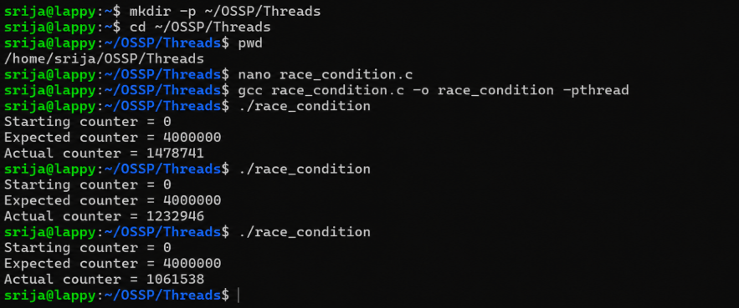
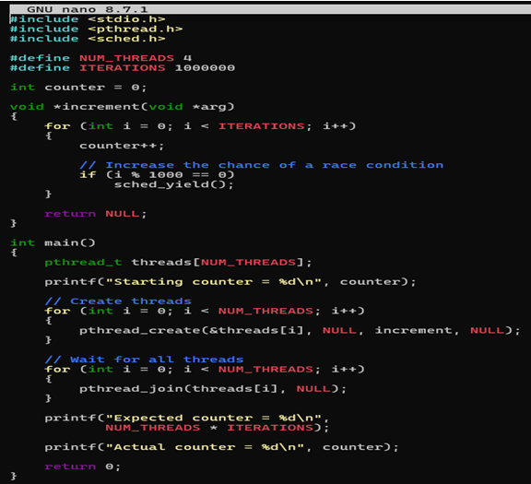
Task2:Modify the previous program using mutex locks (pthread_mutex_lock, pthread_mutex_unlock) and compare the outputs with the race-condition version. Analyze the impact of synchronization.
